Instructions for Adding Module to Project:

If you don’t already have C++ files for your project, add a C++ class to your project. This will add a Primary Game Module to your project. This module is where C++ classes unique to your project would be implement.

Add the LightWeightGridLibrary to Project:

This is done almost entirely inside of the source folder inside of your UProject Folder:

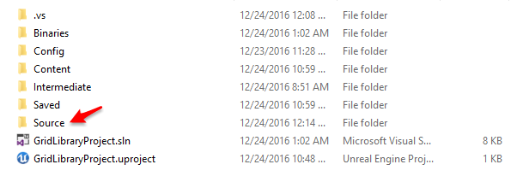

**Step 1: Copy the LightWeightGridLibrary folder into your source directory:**

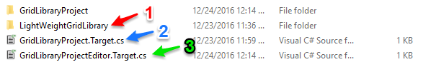

**Step 2: Tell the Unreal Build Tool to build the LightWeightGridLibrary when building your game.**

In your source folder there is a file that is named “YourProjectName”.Target.cs. In the figure above the UProject’s name is GridLibraryProject and the file we’re going to edit is GridLibraryProject.Target.cs, denoted by the blue arrow. Inside Visual Studio, that file will look like this:

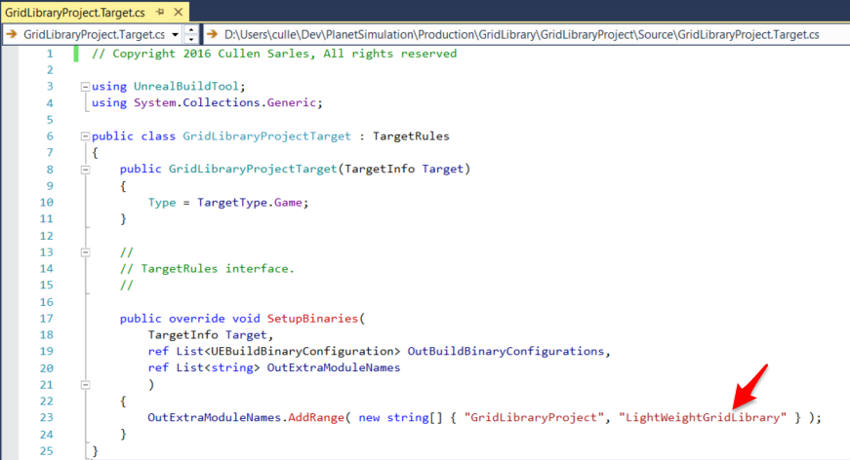

As denoted with the red arrow, we need to modify line 23 to include the LightWeightGridLibrary in the list of extra module names that should be built for your project.

**Step 3: Tell the Unreal Build Tool to build the LightWeightGridLibrary when building your game for the Editor.**

In your source folder there is a file that is named “YourProjectName”Editor.Target.cs. In the figure above the UProject’s name is GridLibraryProject and the file we’re going to edit is GridLibraryProjectEditor.Target.cs, denoted by the green arrow. This file looks almost exactly like the previous file, and we need to make the same edit to it.

**Step 4: Add the GridLibraryProject to the list of modules that your UProject depends upon.**

We now need to make an edit to the UProject file for your project. It’s located in the top folder for your project and has a *.uproject extension:

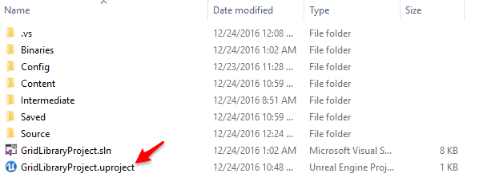

To edit that file, open it with visual studio or your favorite text editor. Inside of that file there will be a set of lines that looks like:

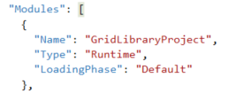

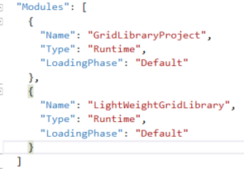Copy and paste everything from the first curly brace up to and including the second curly brace, add a comma between the two sets of curly braces and change the name in the newly created one to be LightWeightGridLibrary. When you’re done it should look like the image on the right.

**Step 5: Add the library to the Primary Game Module’s Dependencies**

If you want to use the LightWeightGridLibary in your own C++ files then you have one more step, otherwise skip to step 6. You need to add the library to the list of public dependencies in the *.Build.cs file for your code module. Find the file in visual studio and modify the line defining those dependencies to into this module, like this:



**Step 6: Regenerate your Visual Studio Project**

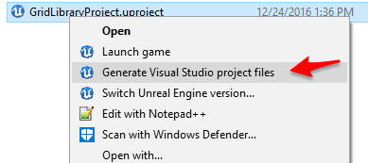With all of that done, you’re ready to regenerate your visual studio project and start using the included grids inside of your editor project. Close everything, right click on your uproject file and choose Generate Visual Studio Project Files. Then open up the visual studio solution and build the project. Close Visual Studio and open up your project in the editor. And congratulations, you’ve added the LightWeightGridLibrary to your project as a second game module and you can now use it to build your project.